ICTWEB509

## Assessment Task 3

# Testing Document for website

# Learner Toolbox

*Author:* Alessandro Ferro

Introduction

**Purpose**

The purpose of this document is to record the testing effectuated on the Learner Toolbox website, to ensure that the requirements have been met and that the website has been developed according to the standards and the expectations of the client.

The results of the testing would serve as the basis for the acceptance or the rejection of the final product by the client.

**Scope**

The testing outlined in this document has been designed and agreed upon by the client and by the developer. The testing has been conducted in the development environment, using the xampp stack to resemble as closely as possible the website production environment.

The testing will cover: link check, cross-browser compatibility, functionalities and error handling.

Link Check

The website relies on a number of internal and external links.

Internal links allow the user to navigate between the various pages of the website, while external links provide the website with resources from other applications.

The link check is done to ensure that there are no broken links in any of the pages. Broken links would lead the users to error pages and would compromise the credibility and the reputation of the client, on top of resulting in bad user experience.

Cross-Browser Compatibility

The website has been designed and developed to ensure consistent rendering between all the major web browser. The technologies adopted and their implementation followed all the modern standard and practices, including the use of languages, tags, libraries and APIs supported by most browser.

Cross-browser compatibility is tested by accessing the website through different browser, visually checking that all the elements have been rendered in line with the original design and layout.

Functionalities

The bulk of this document describes the testing of the behaviour of the website in relation to the interactions of the users with the system. The website functionalities include both client side and server side operations to perform data validation, DOM manipulation, CRUD capabilities, shopping cart and checkout. The server side on top of handling connection and querying of the database, manages user sessions to implement shopping cart functionalities which require data persistency in a stateless environment.

The functionalities have been defined, refined and agreed upon by the client and the developer.

Each functionality has been tested manually, using ad-hoc dummy data. The result of each test has been checked against the expected result to determine success or failure of the test.

Error Handling

Users input can be inconsistent with the parameters accepted by the system, leading to errors. All the forms and the element that allow a user to enter data into the system have been developed to notify the user of the error and to allow the user to correct it, without breaking the website.

The tests have been conducted by purposedly entering invalid data and visually checking how the website reacts.

**User of the System**

Unregistered user

Unregistered users can navigate the website and browse the products, but they cannot access the shopping cart

Registered customer

Registered customers have access to a profile and can add and remove items from their shopping cart. They can also checkout and select between different payment methods.

Admin

Admin has access to the admin dashboard to manage (CRUD) users, categories and products. They also have sales charts and reports available on their dashboard.

Link Check

Method used: npm broken link checker

* Run command

$ blc http://localhost/ICTWEB503.alessandro.ferro.website/ -ro \ --exclude config \ exclude css \ exclude font-awesome



* Results from root directory

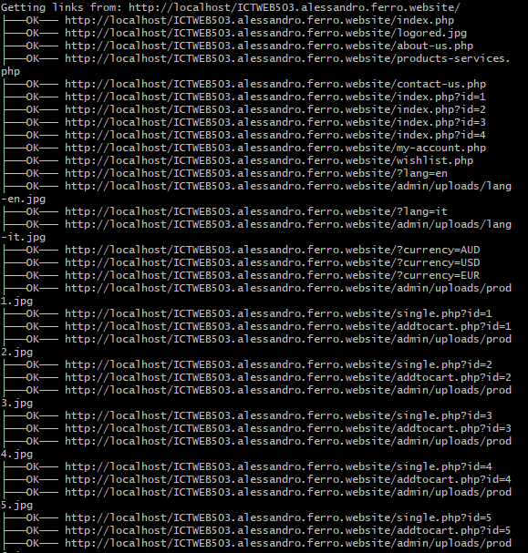

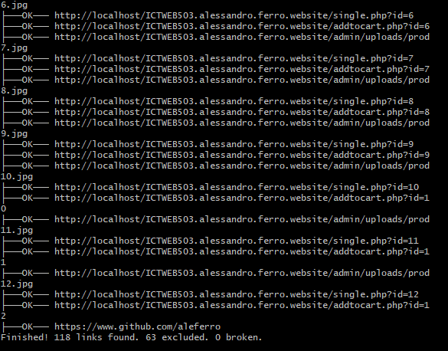

1. Cross Browser compatibility

** The images in the home page may vary due to the banner carousel**

**Home Page**

Chrome

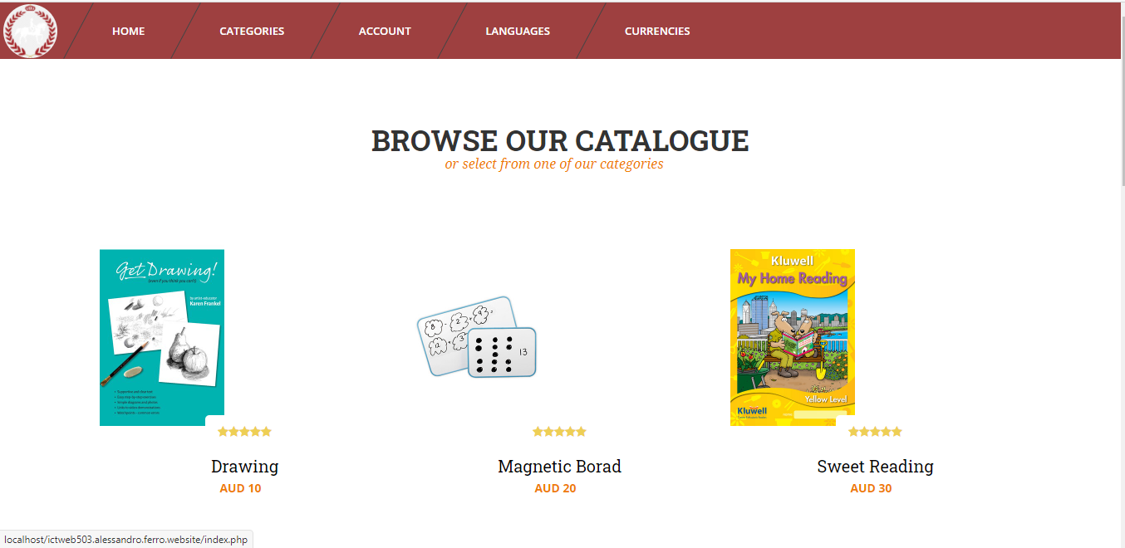

Edge

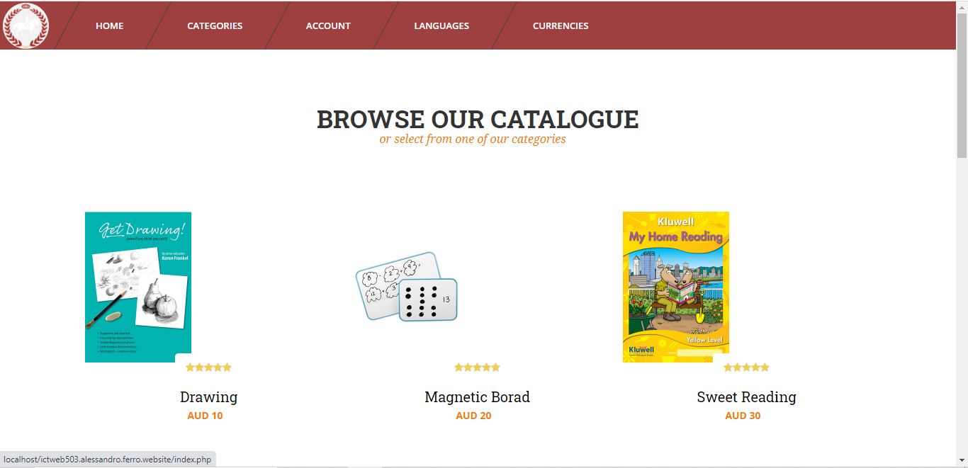

Firefox

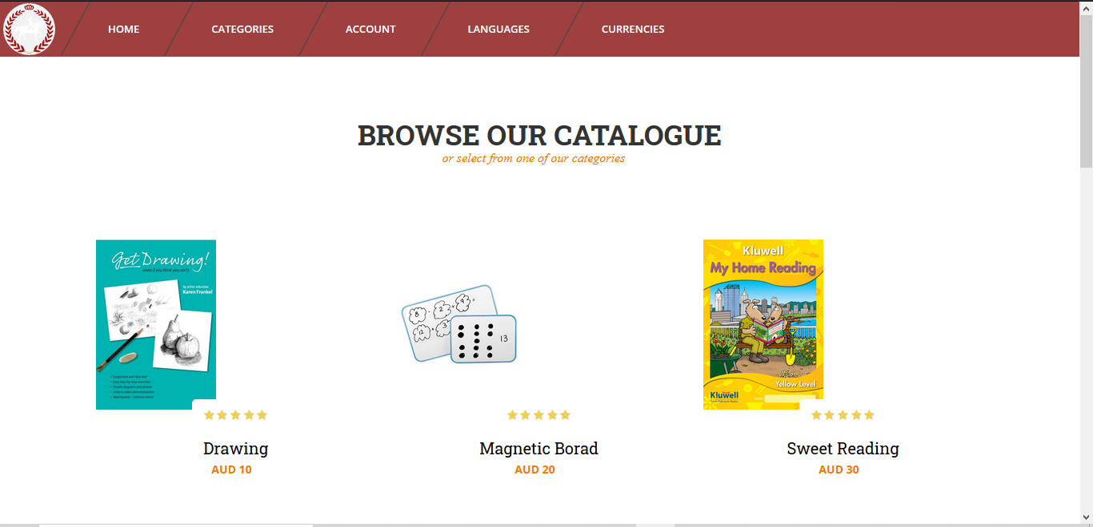

**About Us Page**

Chrome

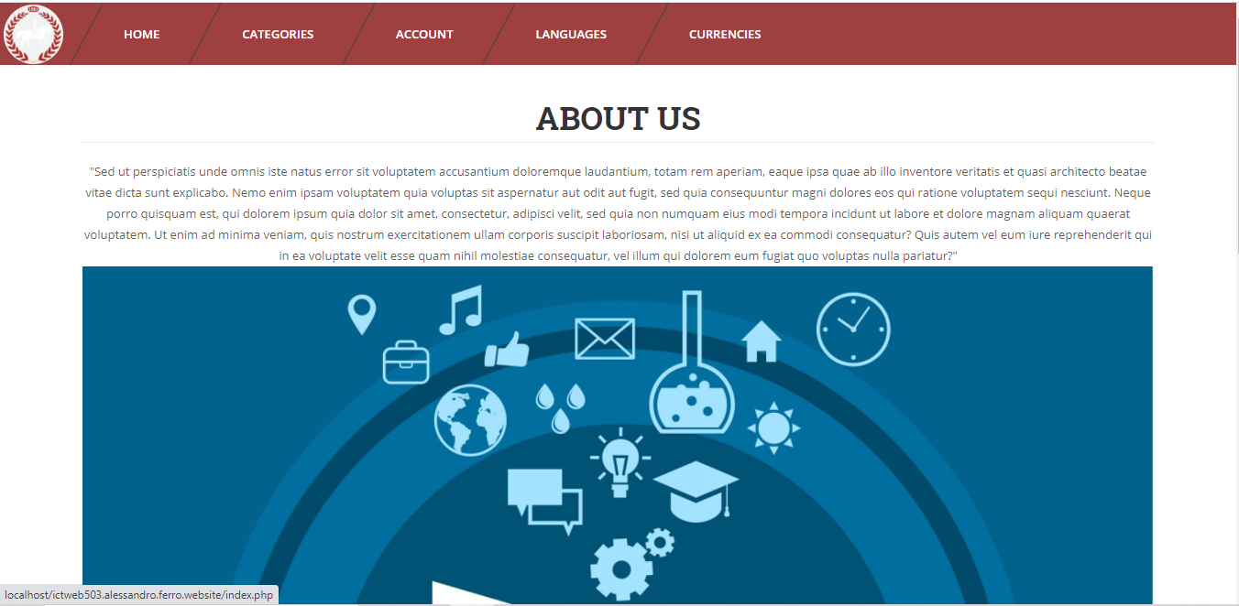

Edge

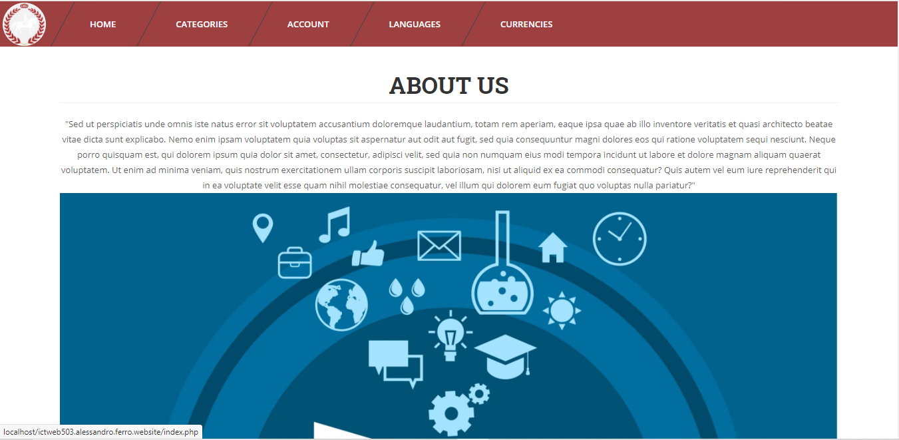

Firefox

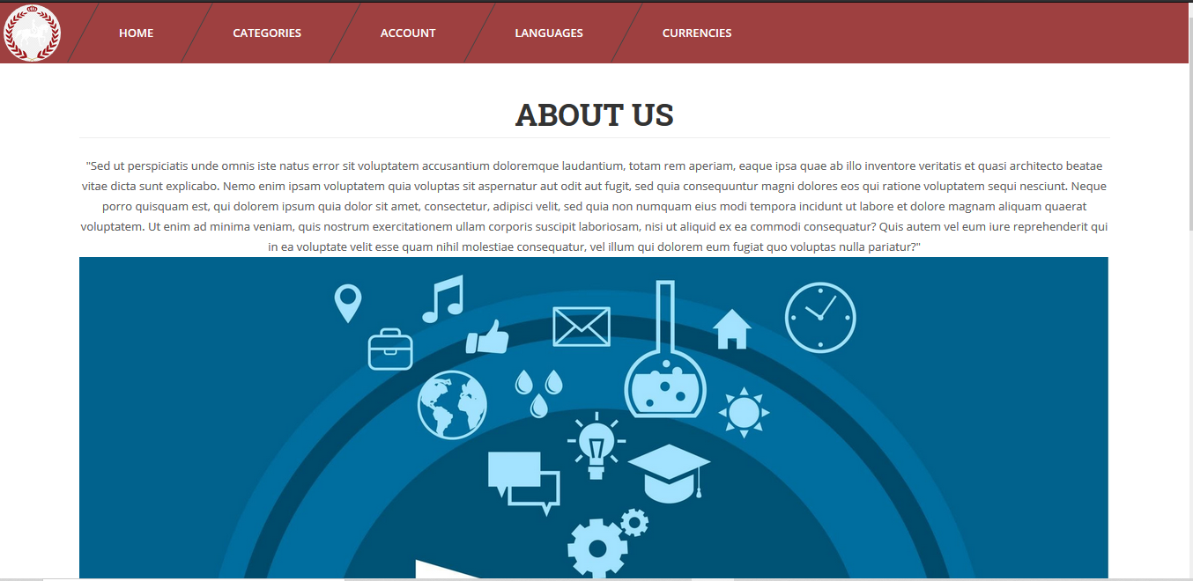

**Contact Us**

Chrome

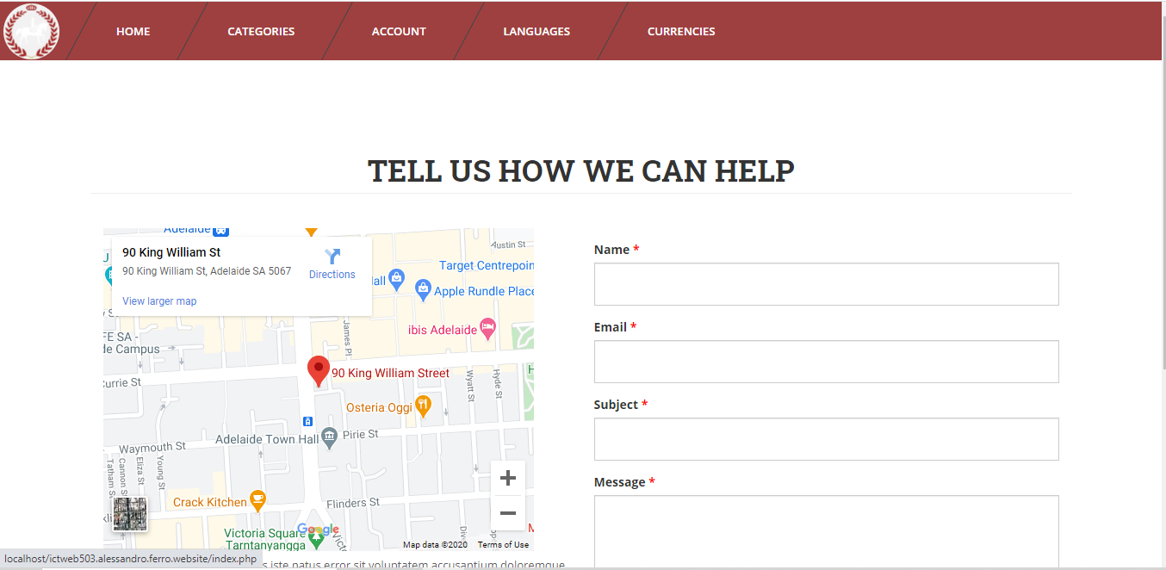

Edge

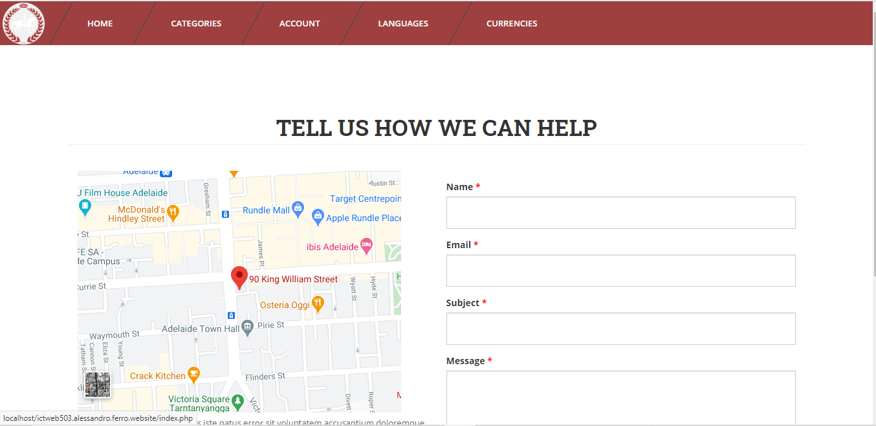

Firefox

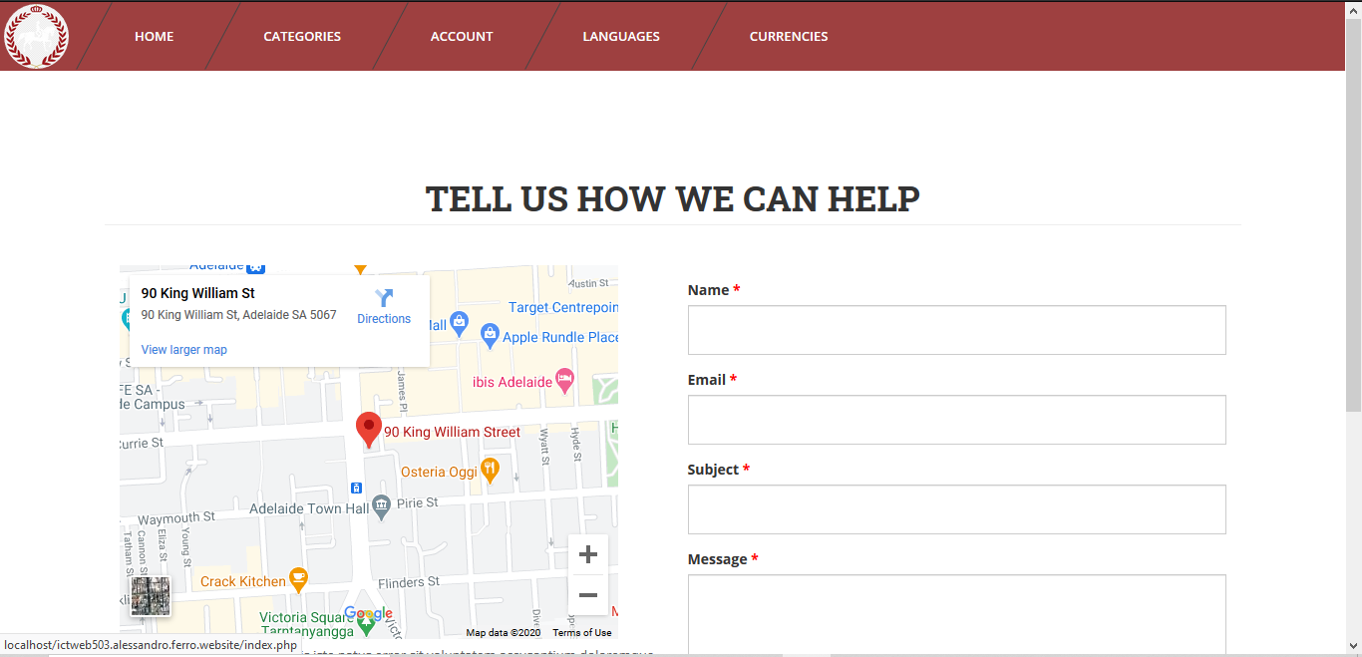

**Products and Services**

Chrome

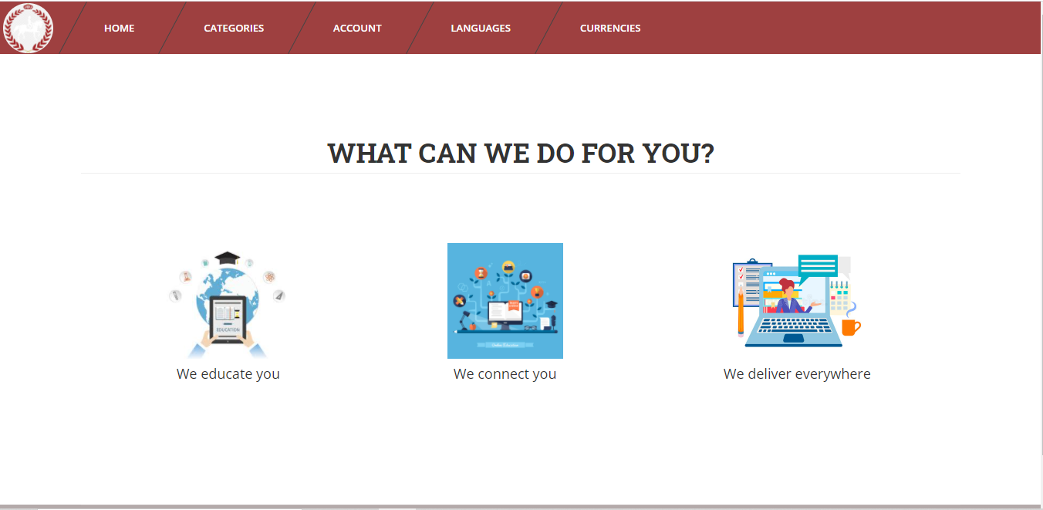

Edge

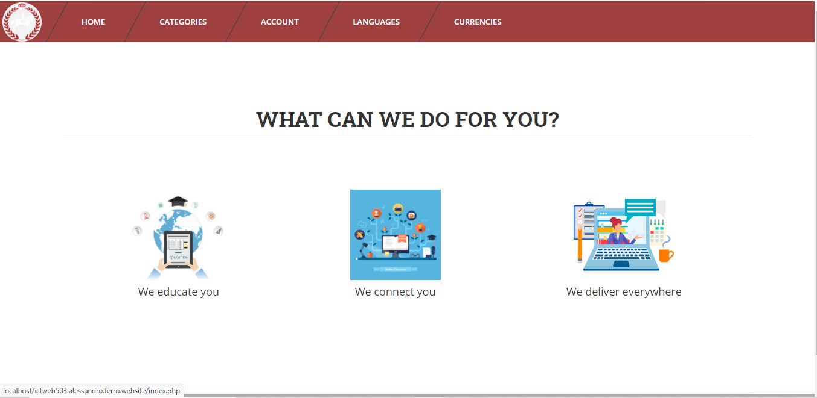

Firefox

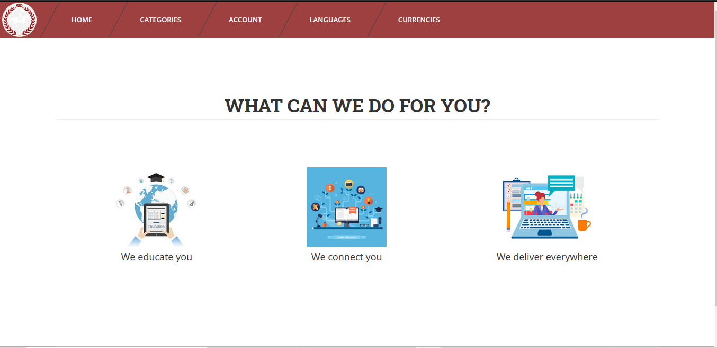

**Login and Register**

Chrome

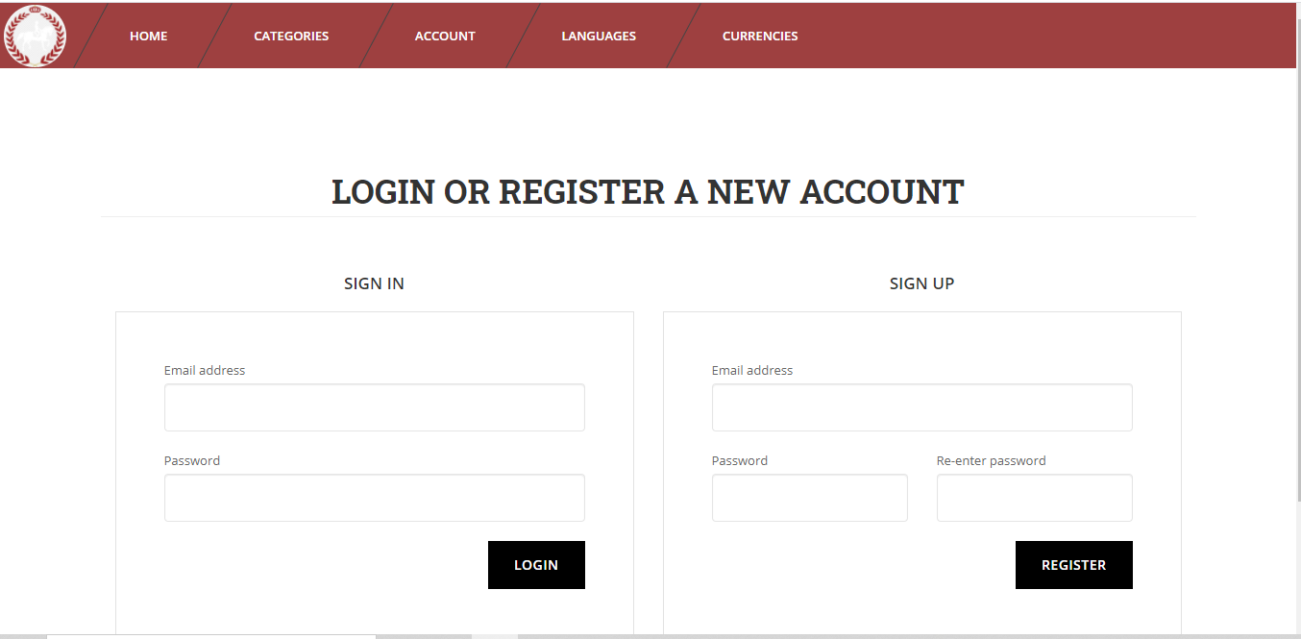

Edge

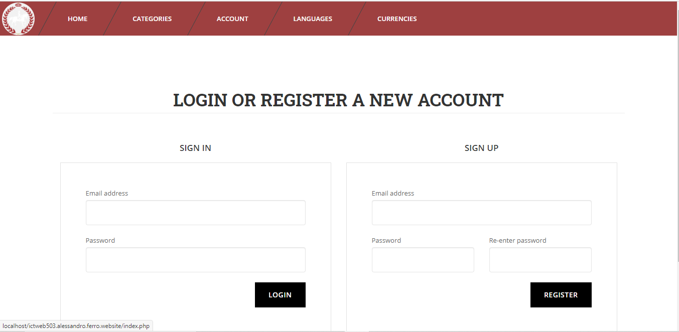

Firefox

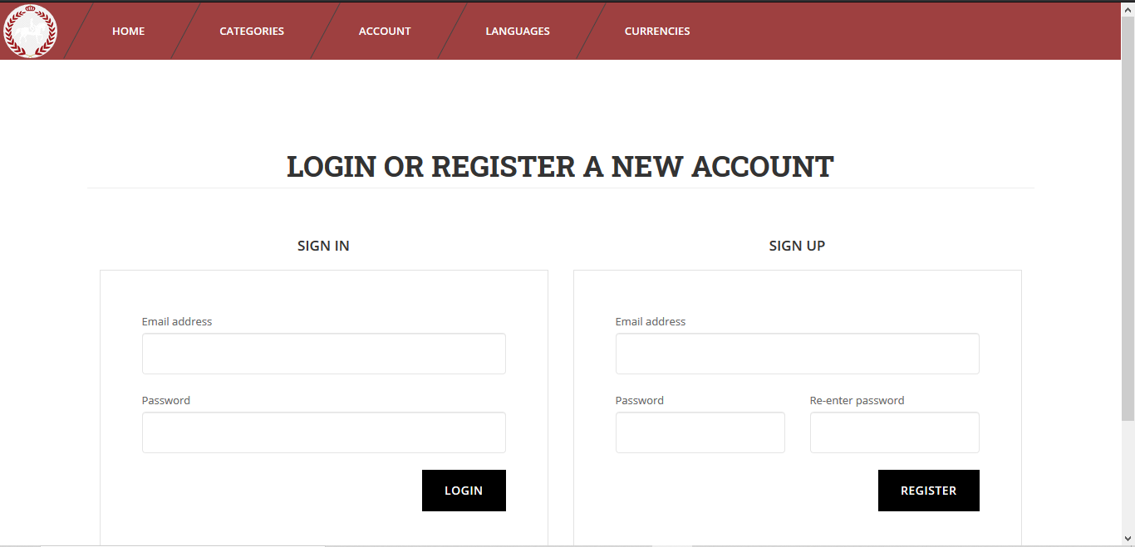

**Product Page**

Chrome

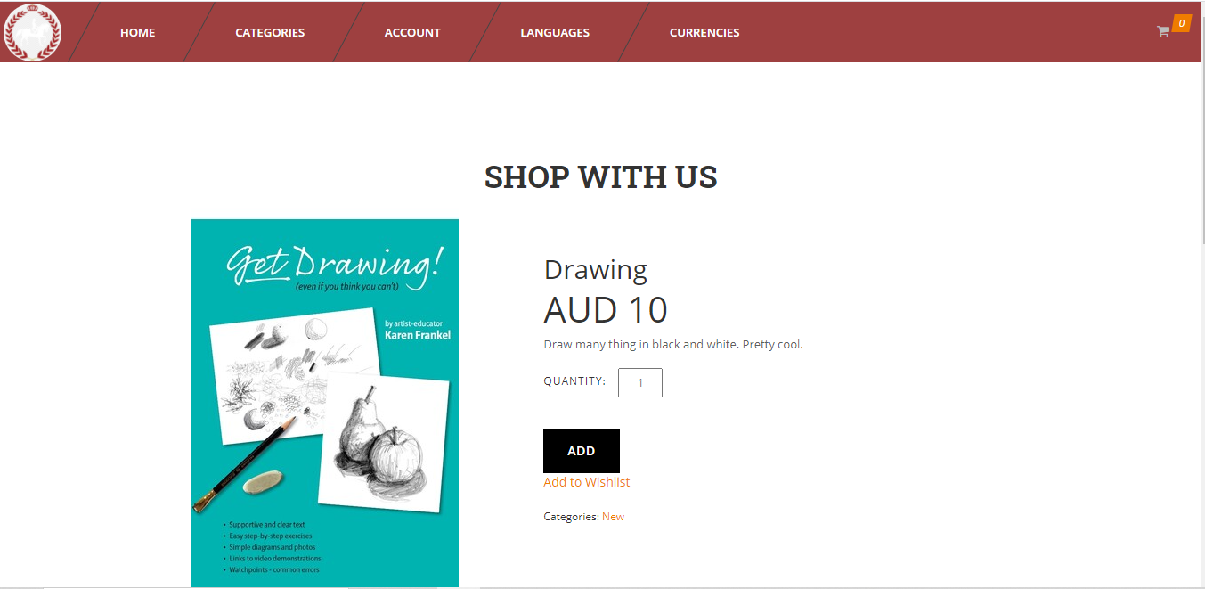

Edge

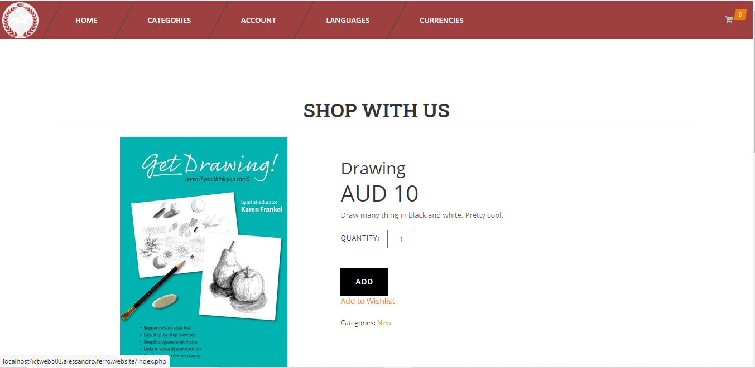

Firefox

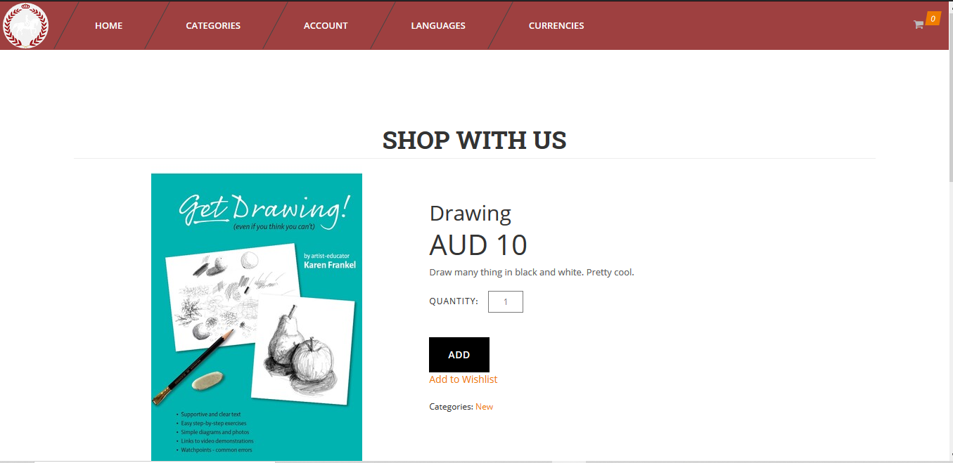

**Wish List**

Chrome

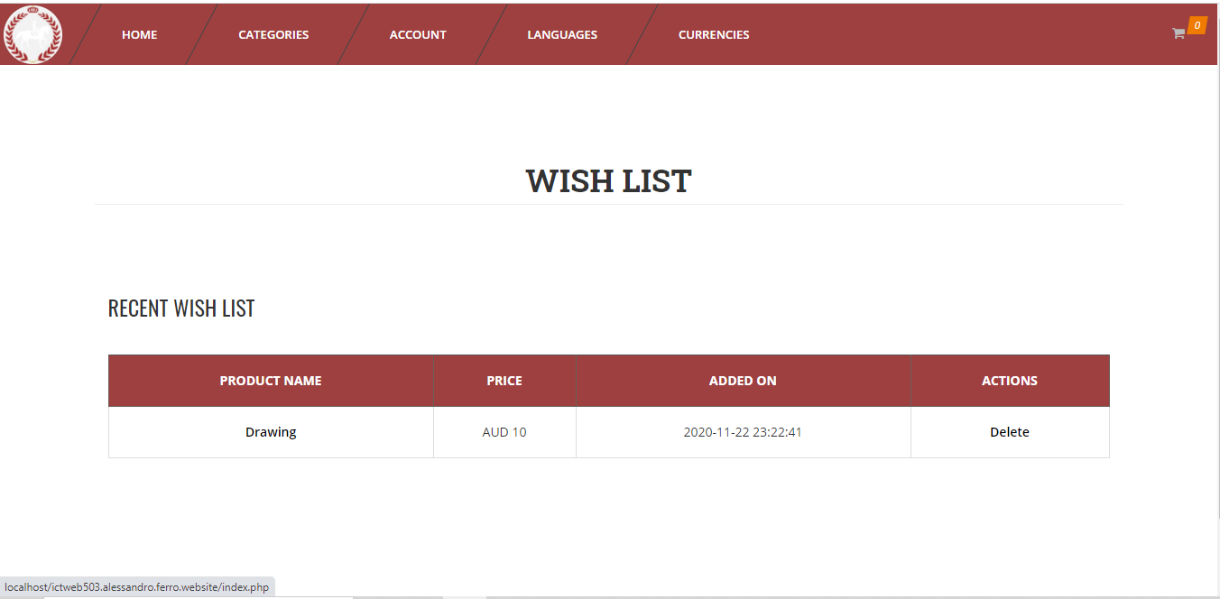

Edge

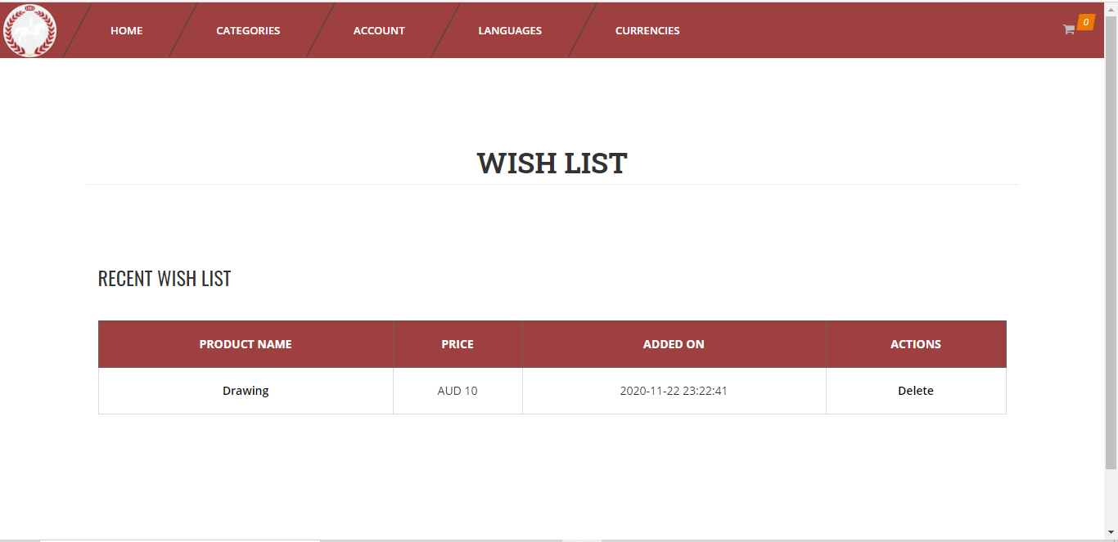

Firefox

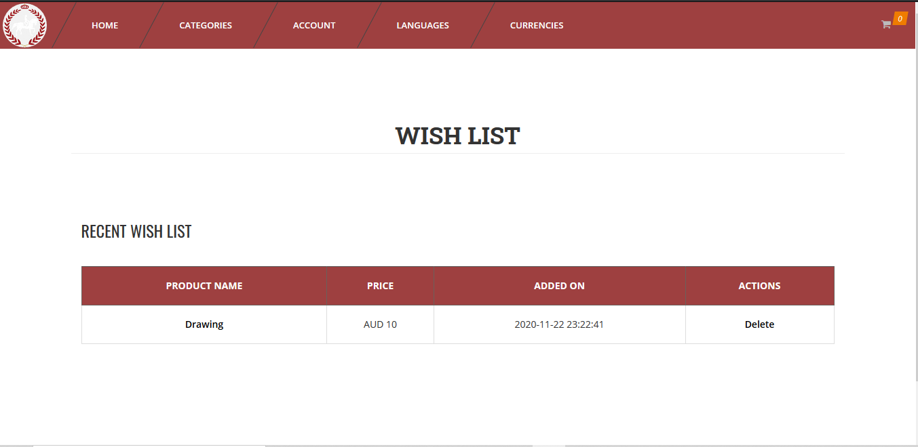

**Shopping cart**

Chrome

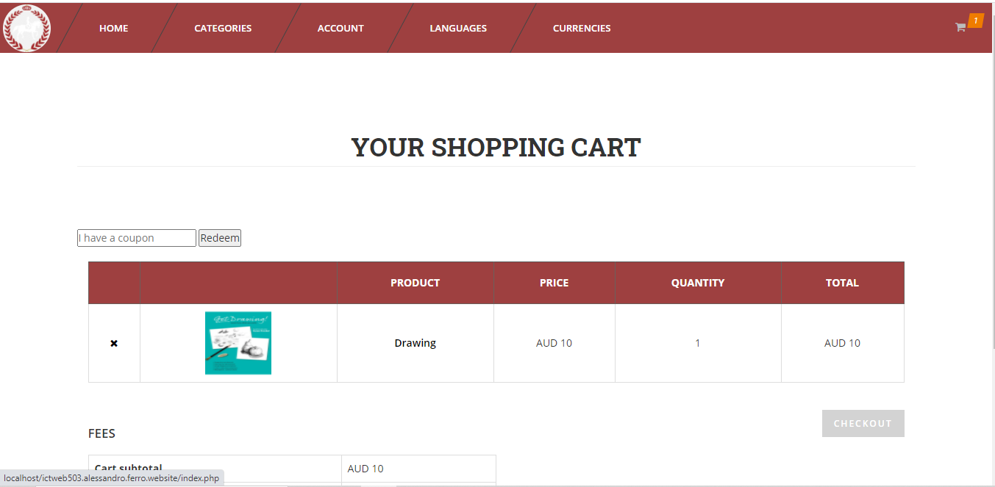

Edge

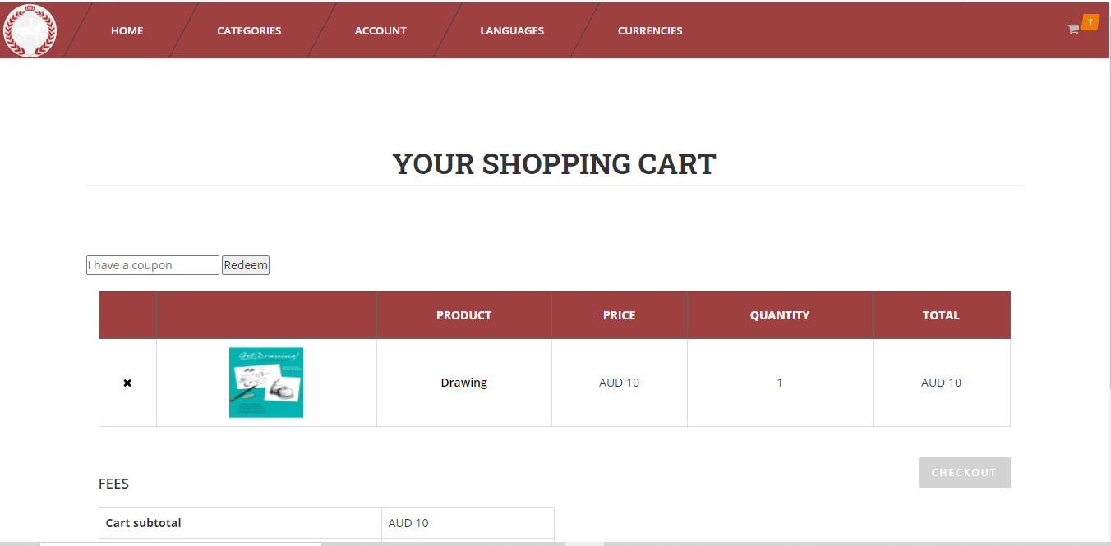

Firefox

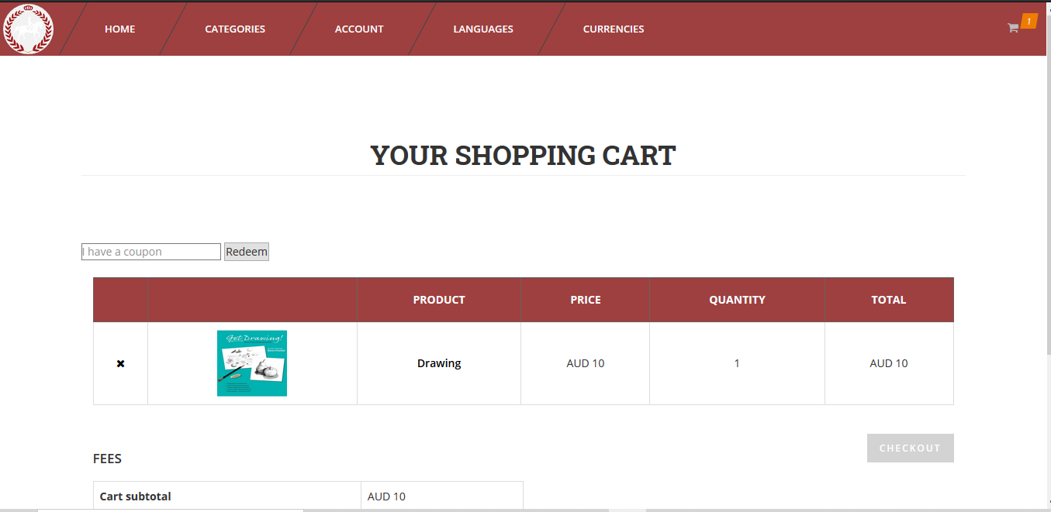

**Checkout**

Chrome

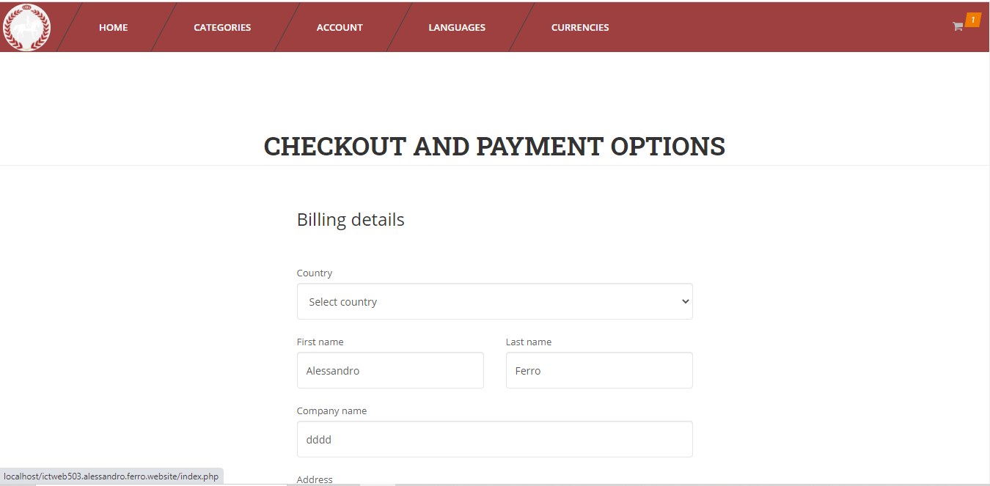

Edge

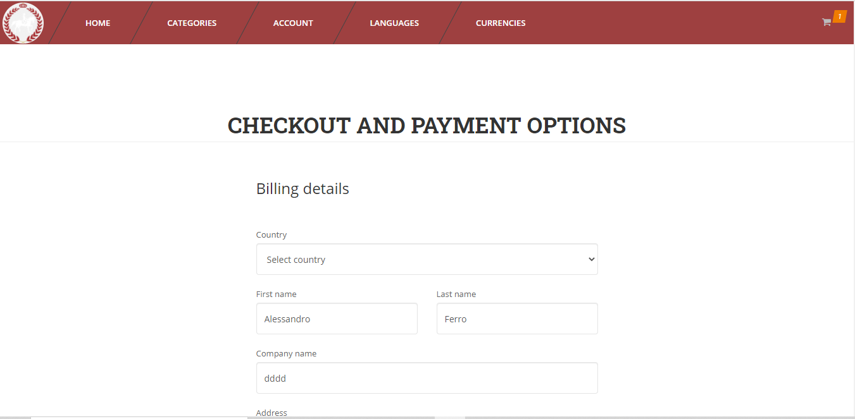

Firefox

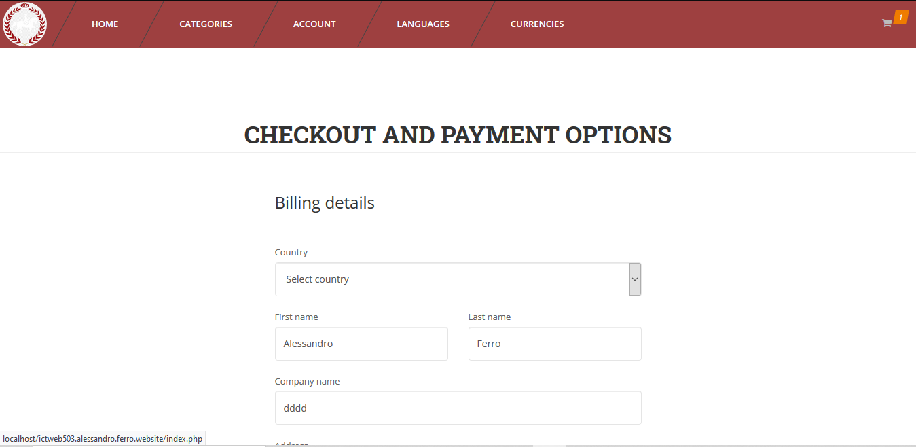

**Account**

Chrome

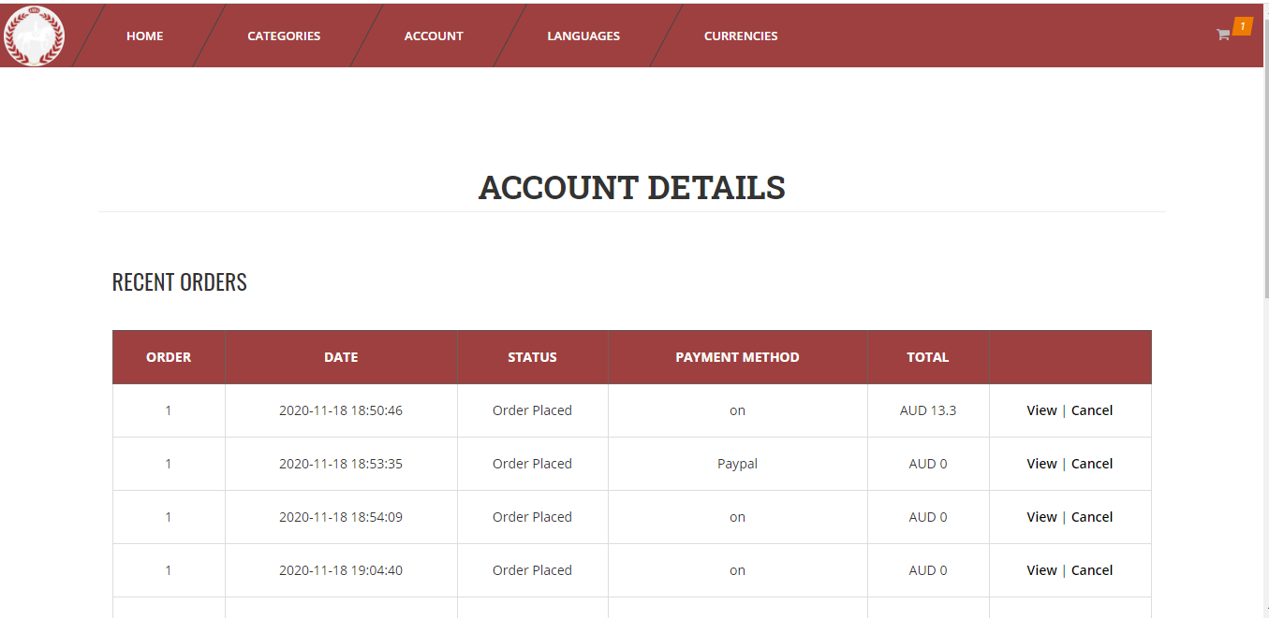

Edge

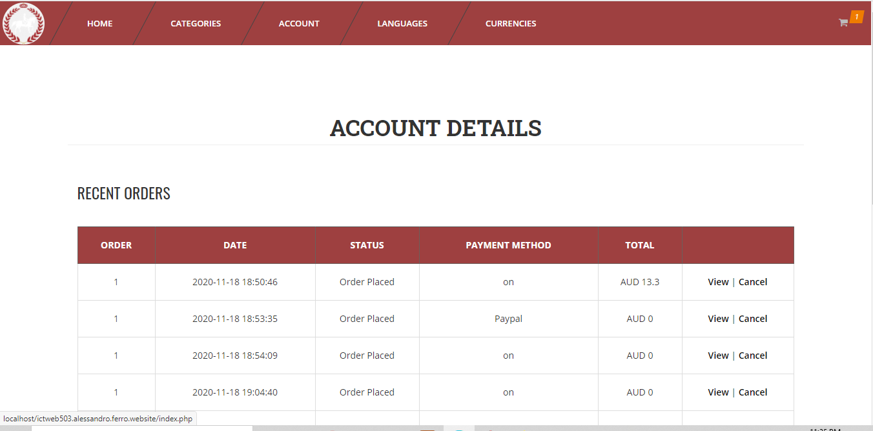

Firefox

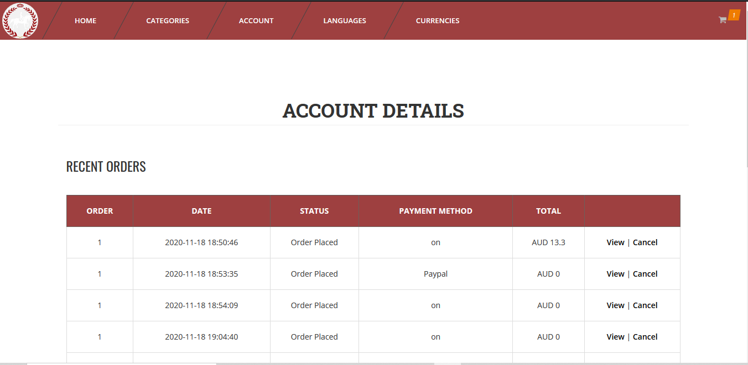

**View order**

Chrome

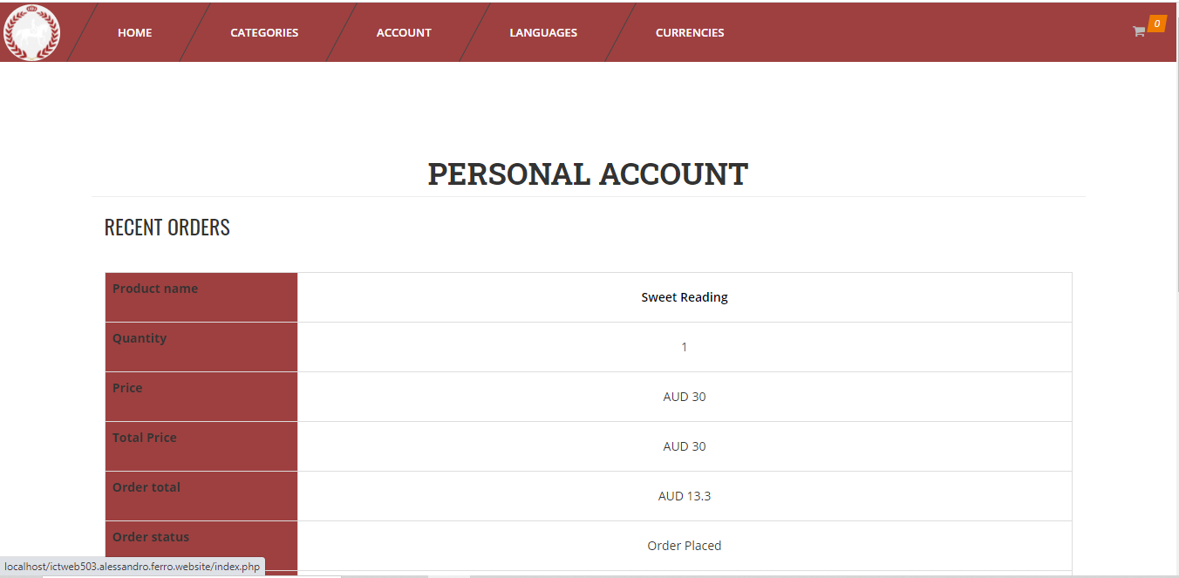

Edge

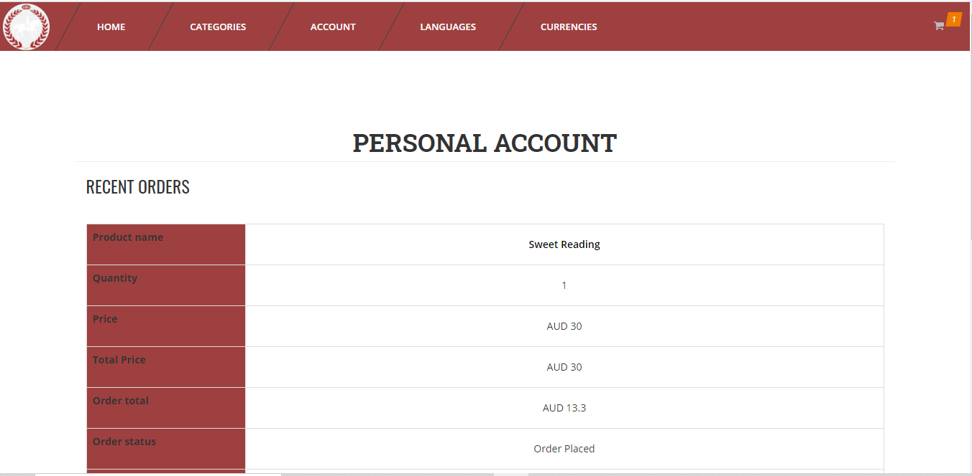

Firefox

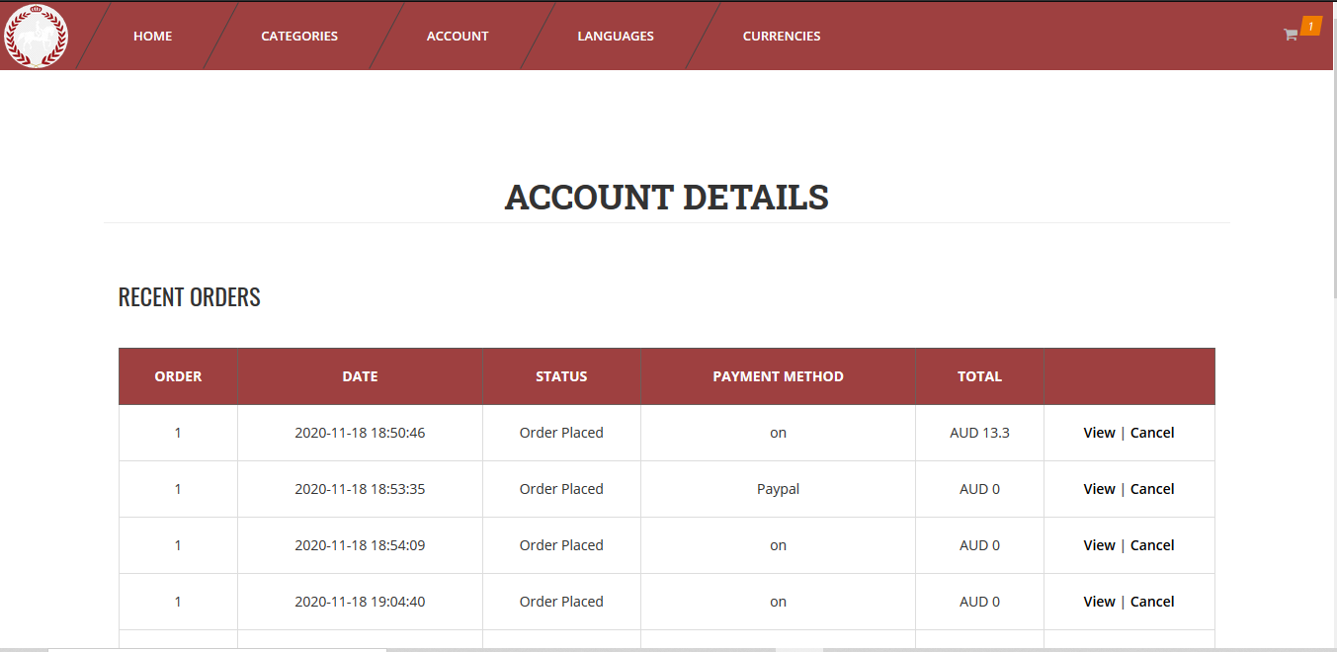

**Admin login**

Chrome

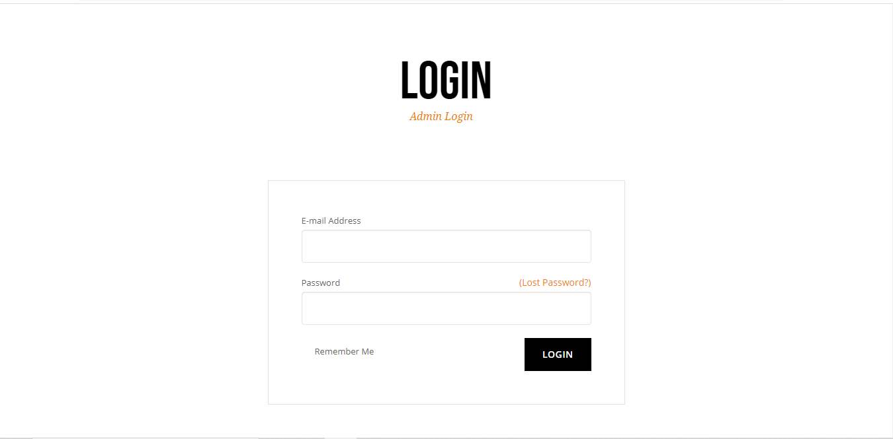

Edge

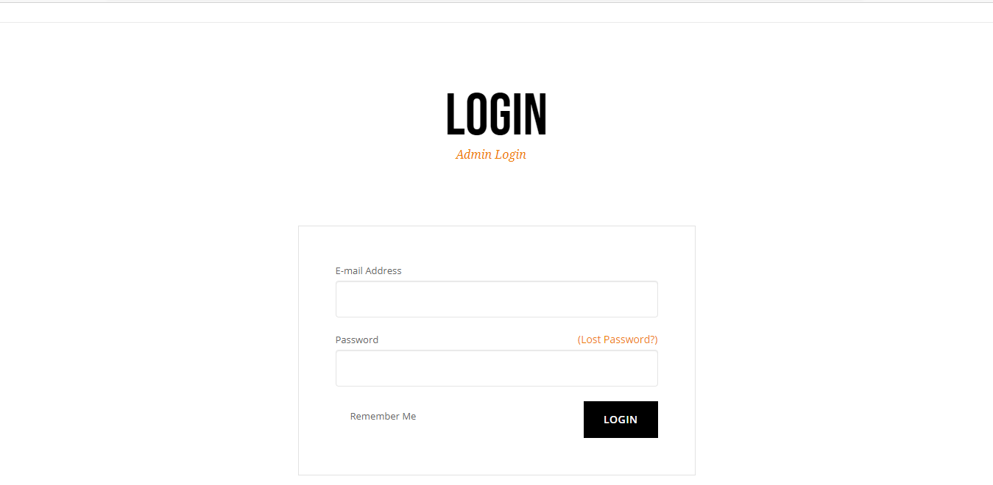

Firefox

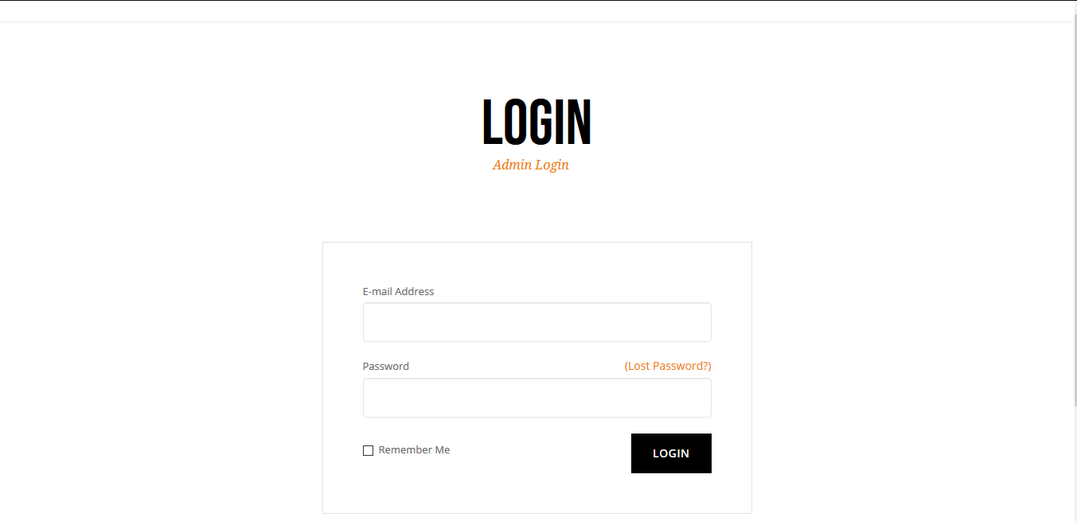

**Admin dashboard**

Chrome

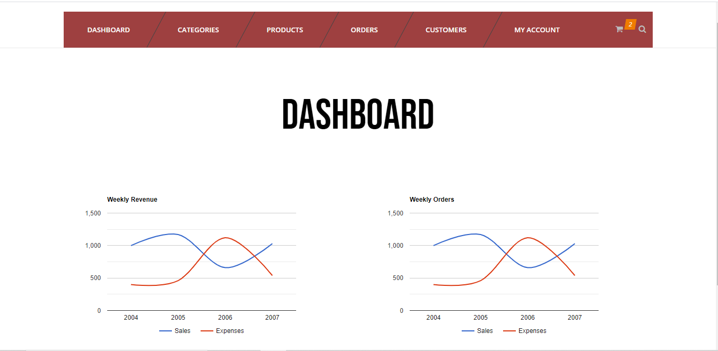

Edge

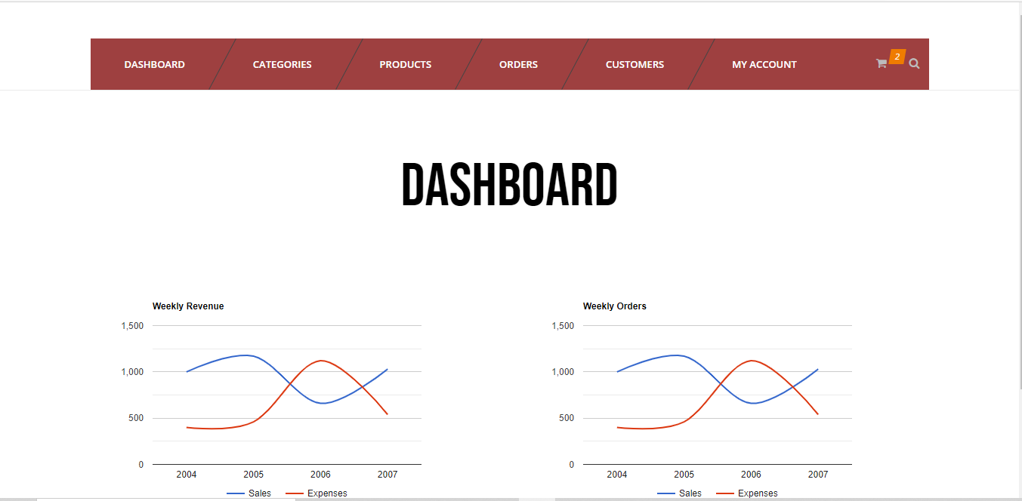

Firefox

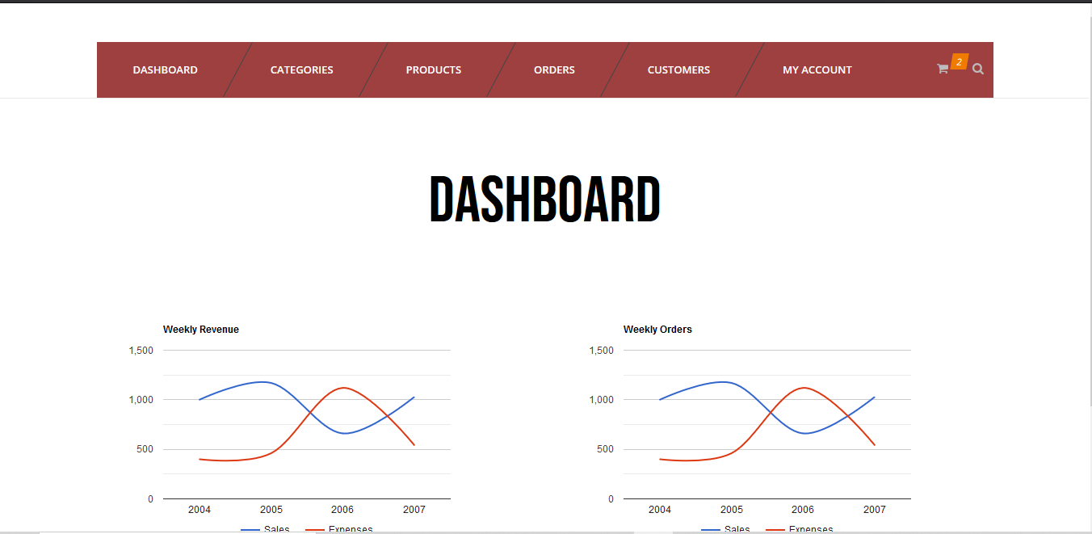

Functionalities

**Login**

|  |
| --- |
|  |
| **Arrow Straight**  Click ‘Sign in’ |
|  |

**Sign up**

|  |  |  |
| --- | --- | --- |
|  |  |  |

|  |
| --- |
|  |
| **Arrow Straight**  Click ‘’Register’ |
|  |

**Add to Cart – Shopping cart**

|  |
| --- |
|  |
| **Arrow Straight**  Click ‘Add’ |
|  |

**Remove from Shopping Cart**

|  |
| --- |
|  |
| **Arrow Straight**  Click X |
|  |

**Add to Wishilist**

|  |  |  |
| --- | --- | --- |
|  |  |  |



Click ‘Add to Wishlist’

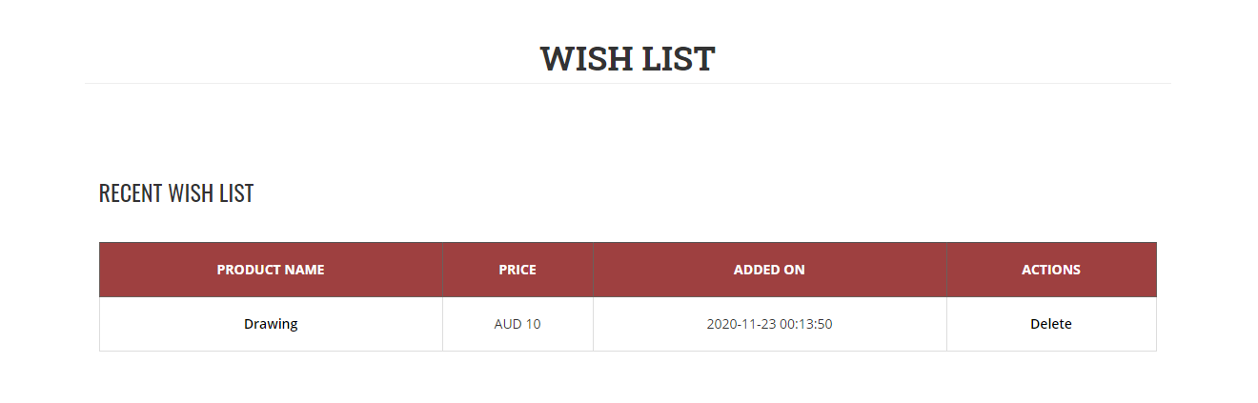

**Send message (Contact Us Page)**

|  |  |  |
| --- | --- | --- |
|  | **Arrow Straight**  Click ‘Send Message’ |  |

**Checkout**

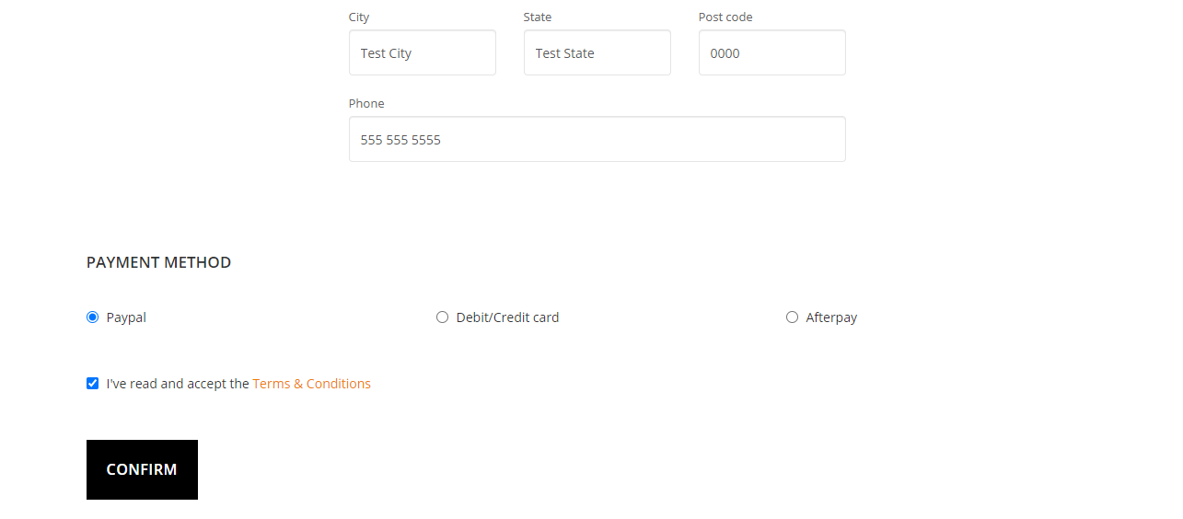



Click ‘Confirm’

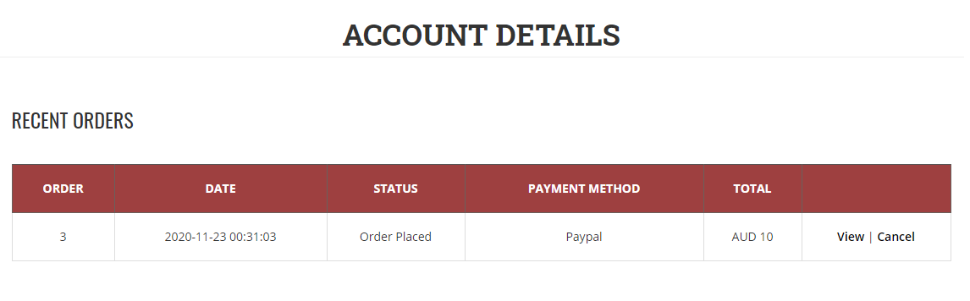

Error Handling

**Register**

Input an email already in the databse

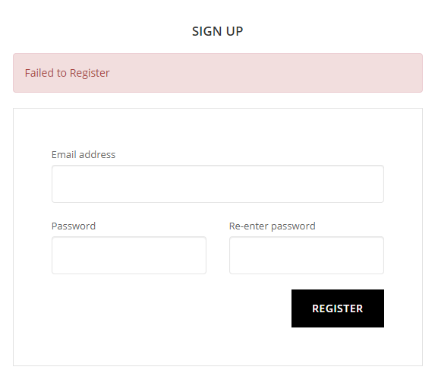

**Login**

Enter invalid login credentials

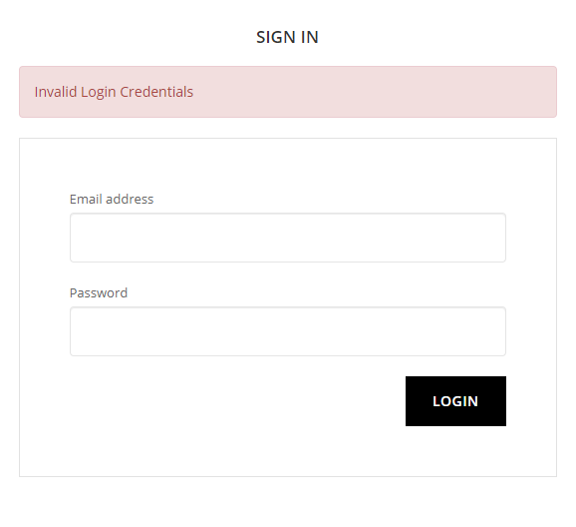

**Checkout**

Accessing the checkout page with no items in the cart

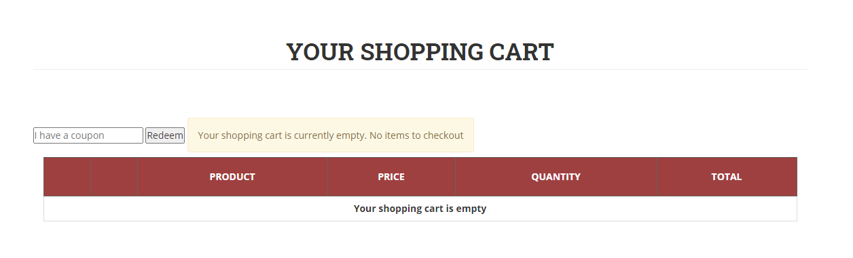

**Coupon**

Trying to redeem an invalid coupon

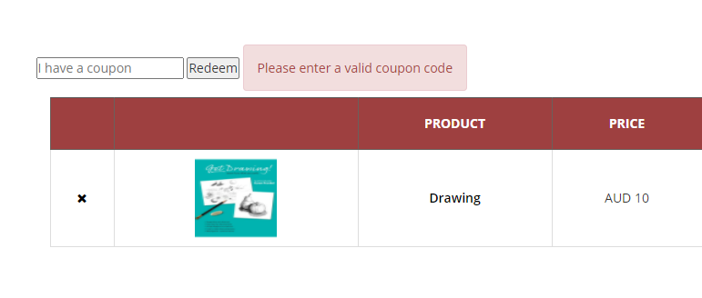

**Coupon**

Trying to redeem a coupon already used

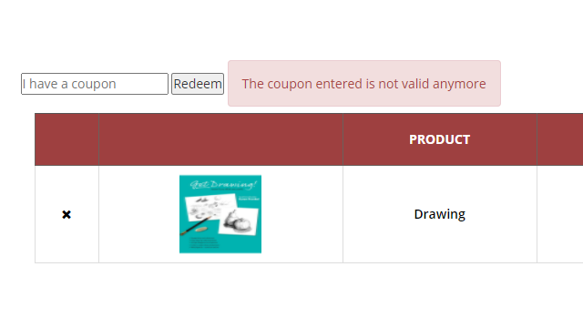

Extra requirements (Includes the requirements that dodn’t find exposition in the previous sections)

Two main sections of the shopping cart

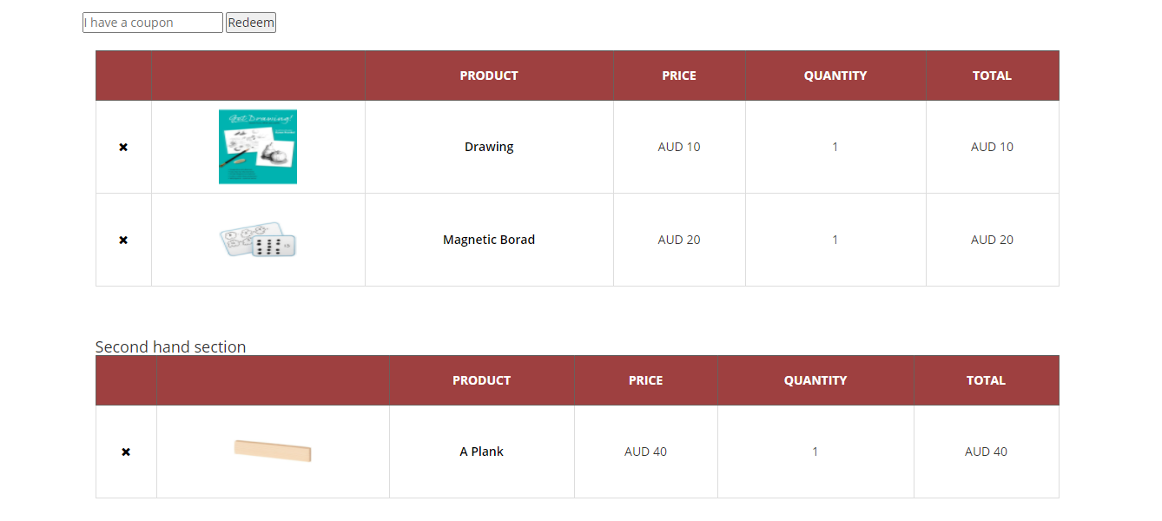

Shopping cart handle more than TEN products

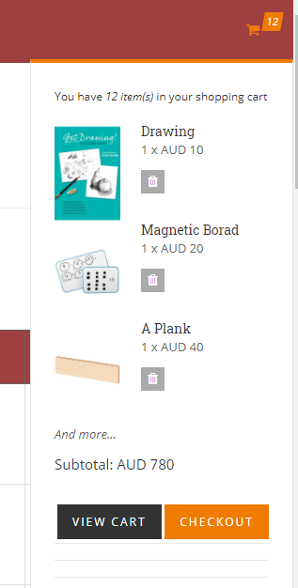

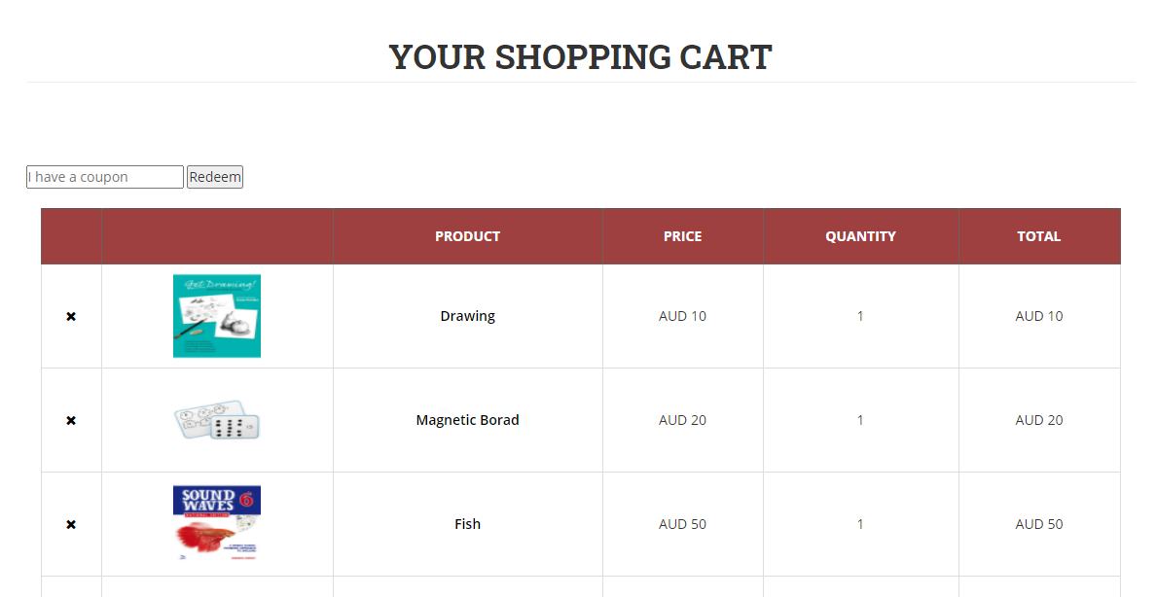

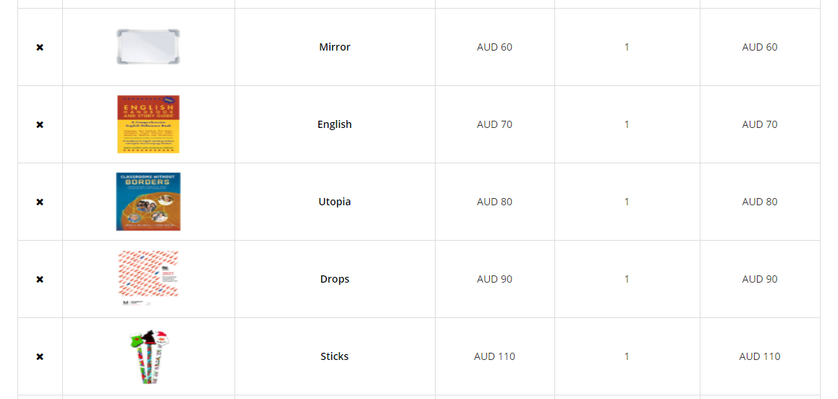

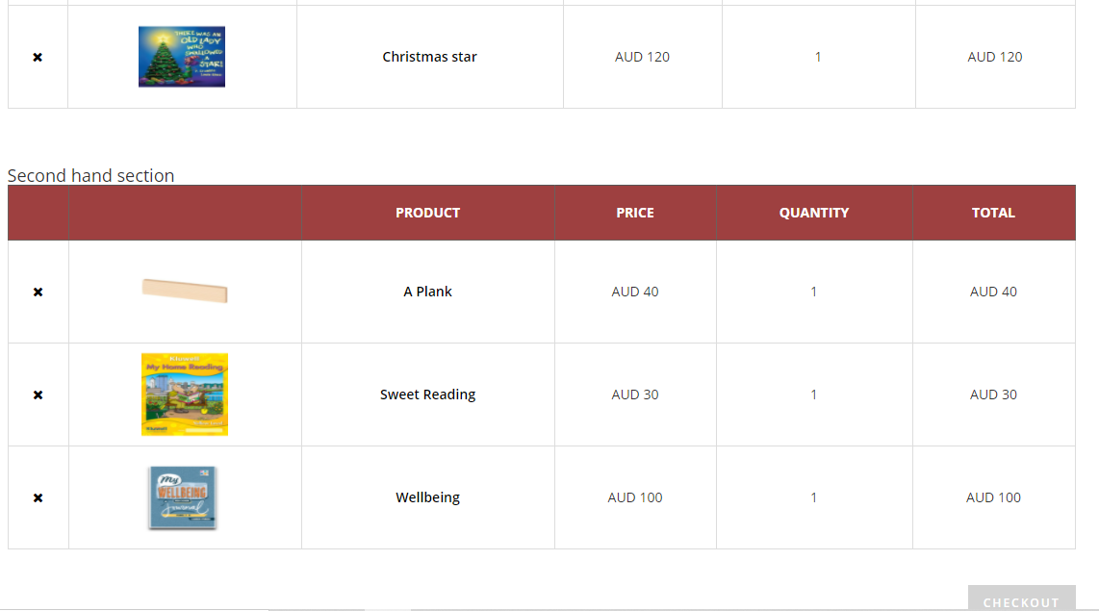

More than TWO types of products available

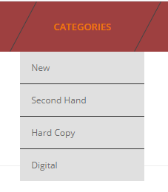

Reviews feature

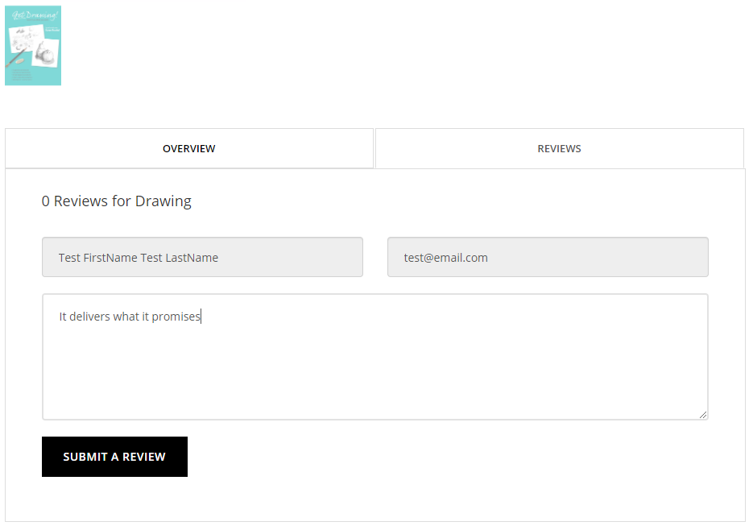

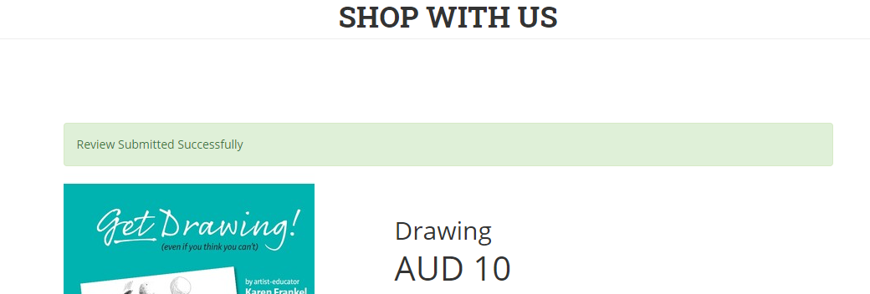

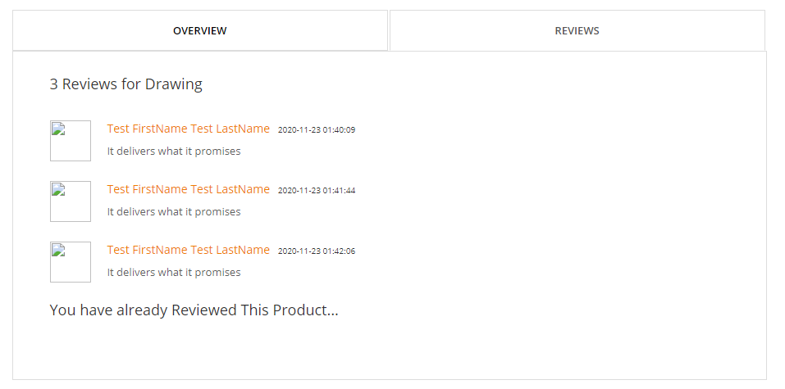

Reccomendation feature

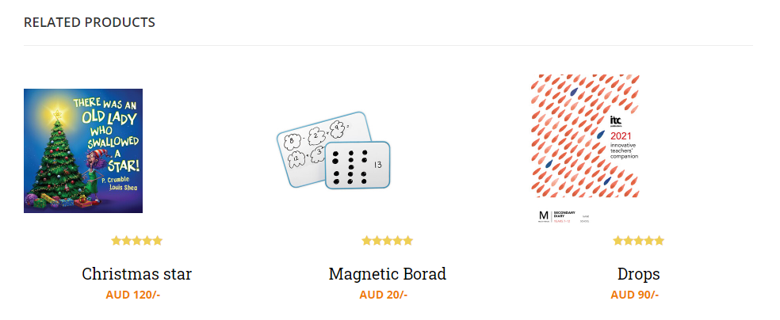

Order history

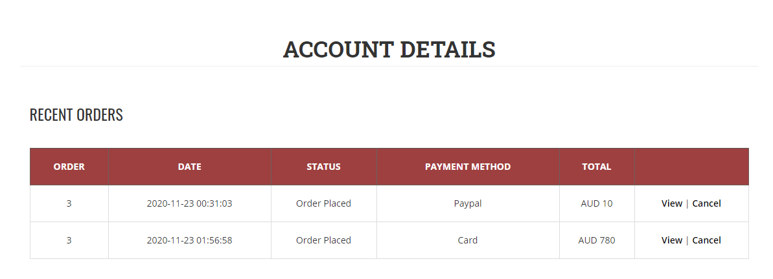

Multiple languages

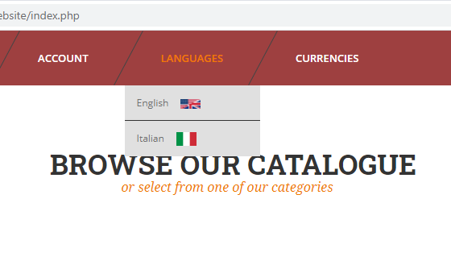

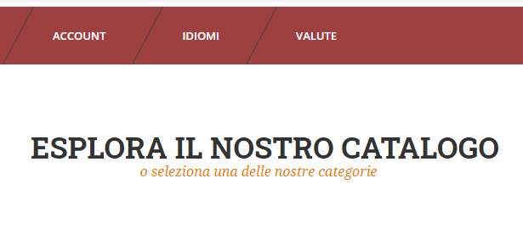

Multiple currencies

Australian Dollar



United States Dollar



Euro

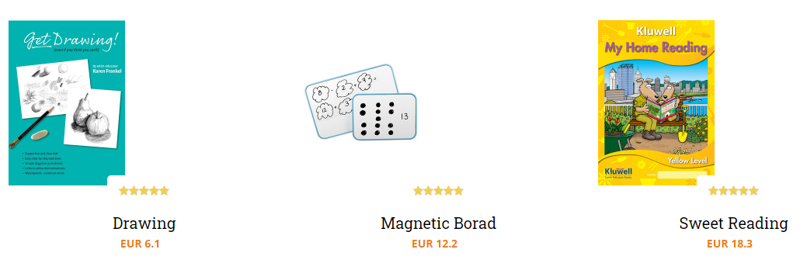

Multiple payment gateway

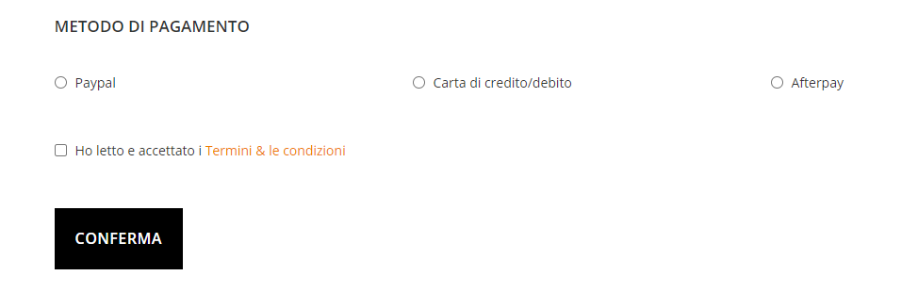

Coupon feature

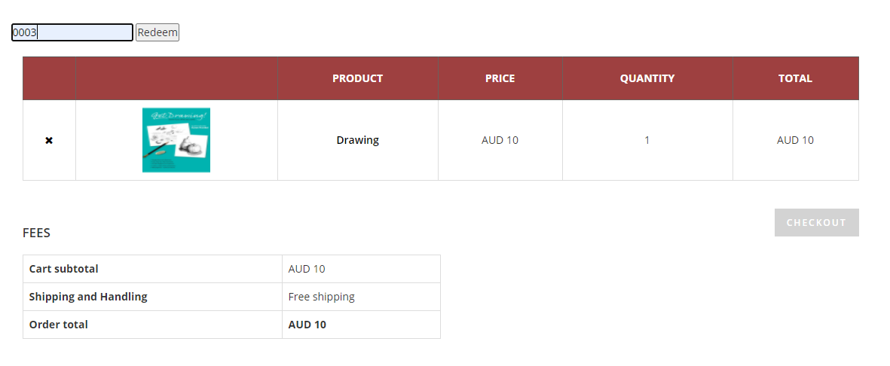

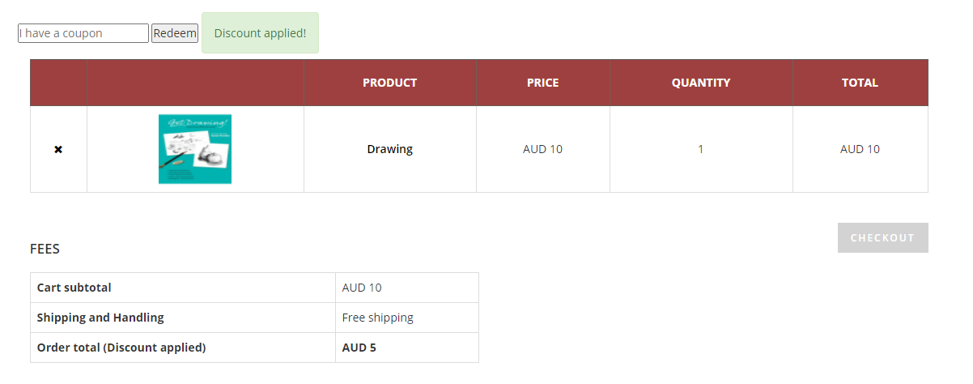

TLS/SSL

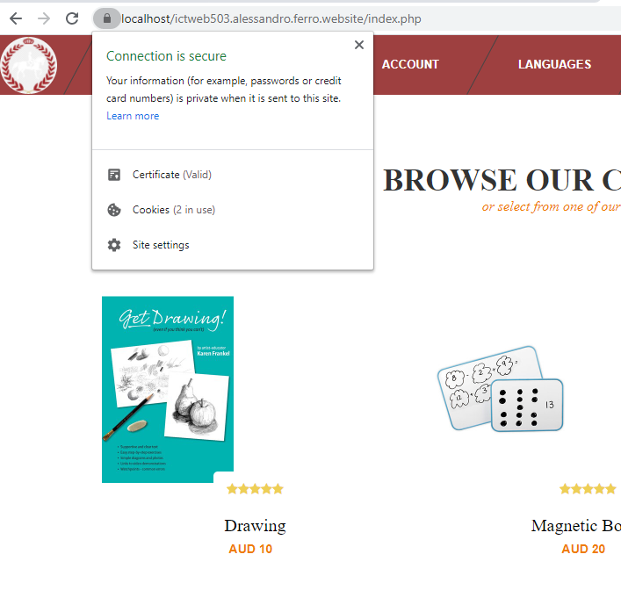

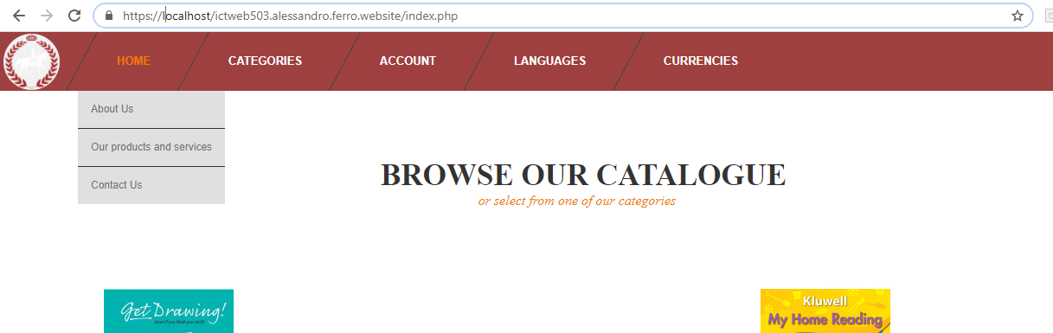



Conclusion

The testing of the Learner Toolbox website didn’t result in any outstanding error and fulfills the requirements of the client.

The link check returned with a result of zero broken links in all the application.When running the program, some files have been left out. Those file include images, assets or libraries that do not contain any code and the purpose of their omission is to speed up the testing progress. Their exclusion doesn’t affect the result of the test.

Cross browser compatibility testing shows a consistent rendering of the website in the browser taken in consideration for the testing. The browser are Chrome, Edge and Firefox and are currently the most used world-wide, indicating that the website is potentially accessible by most people in the world. To ensure that the results are relevant, every page of the website has been tested.

The functionalities have been tested manually by running them with dummmy data, simulating a user interaction with the application. All the functionalities behaved as expected, according to the user authentication and authority level and in line with the performance required by the client.

The possibility of human error when interacting with the system is accounted for. Errors don’t compromise the user experience, are clearly signaled and the user can act on them immediately without needing any extra navigation.

The extra features required by the client have been implemented and tested as part of the larger application to ensure their integration.

At the current stage, pending the client approval, the development of the Learner Toolbox website is considered concluded.